MD2201: Data Science

Name of the student: Shrinivas Hatyalikar Roll No. 24

Div: B Batch: B1

Date of performance: 29/09/22

Experiment No.3

Title: Hypothesis Testing
Aim: i. To perform hypothesis testing for single sided tail.
ii. To perform hypothesis testing for Two-sided tail.

Software used: Programming language R.

Code Statement:
- Suppose the manufacturer claims that the mean lifetime of a ball bearing is 10000hours. The auditing team stated that the mean lifetime is less than what is claimed. On the basis of a randomly chosen sample of 50 ball bearings as given in the dataset, at 0.05 significance level, can we reject the claim of the manufacturer? What will be your interpretation if the significance level is made as 0.01? Consider the data set titled “Hypothesis_csv1.csv”.

- The nutrition label on a bag of potato chips says that a one ounce (28 gram) serving of potato chips has 130 calories and contains ten grams of fat, with three grams of saturated fat. A random sample of 35 bags yielded a sample mean of 134 calories with a standard deviation of 17 calories. Is there evidence that the nutrition label does not provide an accurate measure of calories in the bags of potato chips? We have verified the independence, sample size, and skew conditions are satisfied. Take alpha as 5% and 1%.

Code:

f<-read.csv("Hypothesis_csv1.csv")
cat("Null hypothesis = 10000")
cat("\nAlternate Hypothesis < 10000")
cat("\nalpha = 0.05")
observed<-mean(f$Life_Hrs)
cat("\nObserved = ",observed)
mean<-10000
se<-sd(f$Life_Hrs)/sqrt(50)
cat("\nStandard error = ",se)
pv<-pnorm(observed,mean,se)
cat("\nP value = ",pv)
if(pv<0.05){
cat("\nclaim to be rejected for significance level = 0.05")

}else{
cat("\nclaim cannot be rejected for significance level = 0.05")
}
if(pv<0.01){
cat("\nclaim to be rejected for significance level = 0.01")
}else{
cat("\nclaim cannot be rejected for significance level = 0.01")
}

#Question 2

cat("\n\nNull hypothesis = 130")
cat("\nAlternate hypothesis != 130")
observed
mean1<-130
pv1<-pnorm(134,130,17/sqrt(35),lower.tail = F)*2
cat("\np-value",pv1)
if(pv1<0.05){
cat("\nclaim to be rejected for significance level = 0.05")
}else{
cat("\nclaim cannot be rejected for significance level = 0.05")
}
if(pv1<0.01){
cat("\nclaim to be rejected for significance level = 0.01")
}else{
cat("\nclaim cannot be rejected for significance level = 0.01")
}

Results: Display the output obtained on R console for all the cases.

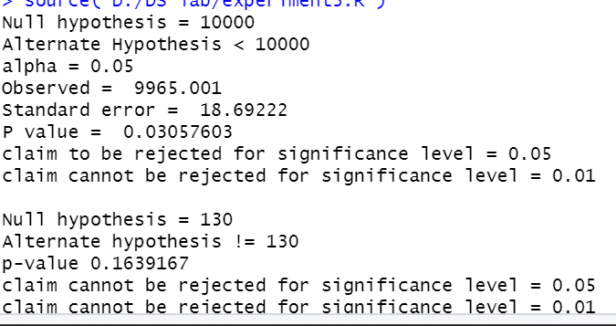

Conclusion:

In Case 1, a single-sided tail hypothesis test is conducted. The claim should be rejected when the significance level is 0.05 because the Pvalue is less than 0.05. The assertion cannot be disproved when the significance level is 0.01 since the Pvalue is bigger than 0.01. The two-sided tail theory is tested in instance 2. For both significance levels, 0.05 and 0.01, the Pvalue is higher. Thus, the assertion cannot be refuted.

